

**DEPARTMENT OF ELECTRICAL AND ELECTRONICS ENGINEERING**

**(2023-2024)**

**Internship and mini project based on python programming with Data Engineer**

**Project title**

**Scholastic achievement Dashboard**

**In**  **accordance with requirement of degree of**

**BACHELOR OF TECHNOLOGY**

**In**

**ELECTRICAL AND ELECTRONICS ENGINEERING**

**Submitted by:**

**K.NAVYA**

**21KQ1A0213**

**Date: 11-06-2024**

**STUDENT’S DECLARATION**

I am K.NAVYA a student of **Bachelor of Technology** Program, Reg. No. **21KQ1A0213** of the Department of **Electrical and Electronics Engineering, PACE Institute of Technology and Sciences, Ongole** do hereby declare that I have completed the **Internship and mini project based on python programming with data engineer.**

**(Signature of student & date)**

**OFFICIAL CERTIFICATION**

This is to certify that **K.NAVYA**Reg. No. **21KQ1A0213** has completed the **Internship and mini project based on python programming with data engineer** under my supervision as a part of partial fulfillment of the requirement for the Degree of **Bachelor of Technology** in the **Electrical and Electronics Engineering**

This report is accepted for evaluation.

**Faculty Mentor Head of the Department**

PROJECT TITLE

SCHOLASTIC ACHIEVEMENT

Abstract: Scholastic achievement, often measured through student marks, is a key indicator of educational outcomes and a critical factor in the academic development of students. This study examines various determinants of scholastic achievement, including socio-economic status, teaching methodologies, school infrastructure, and student motivation. Data from a diverse sample of students marks.

Discription: A scholastic achievement description for student marks typically includes several key elements to provide a comprehensive overview of the student's academic performance. Here’s a structured description,it defines the over view of the subject names, total mraks maximum marks,minimum marks with corresponding requirements and the lowest and highest marks in each person with their significates of the student response.

Requirements:Analyzing students' marks, there are several key requirements to consider. These requirements ensure that the process is fair, accurate, and useful for all stakeholders. Here are the main requirements:

**1. Data Collection**

* **Accurate Recording**: Ensure that marks are recorded accurately without errors.
* **Consistent Format**: Use a standardized format for recording marks (e.g., percentages, grades, points).
* **Timely Entry**: Record marks in a timely manner to avoid backlogs and ensure up-to-date information.

**2. Data Management**

* **Secure Storage**: Keep students' marks secure to protect their privacy.
* **Backup Systems**: Implement regular backup procedures to prevent data loss.
* **Access Control**: Restrict access to marks to authorized personnel only.

**3. Data Processing**

* **Normalization**: Normalize marks if they come from different sources or scales to ensure comparability.
* **Aggregation**: Aggregate marks for different subjects, terms, or assessments to provide a comprehensive view.
* **Weighting**: Apply appropriate weights to different components (e.g., exams, assignments) as per the curriculum requirements.

**4. Analysis and Reporting**

* **Statistical Analysis**: Perform statistical analysis to identify trends, outliers, and areas needing improvement.
* **Grade Calculation**: Calculate final grades based on predefined criteria and formulae.
* **Feedback Generation**: Provide constructive feedback based on the marks analysis to guide student improvement.

**5.Support Systems**

* **Training for Educators**: Provide training for teachers and staff on how to accurately record and manage marks.
* **Technical Support**: Offer technical support for any digital systems used in marks management.

**6. Review and Feedback**

* **Regular Reviews**: Conduct regular reviews of the marking and reporting process to identify and implement improvements.
* **Feedback Mechanism**: Establish a mechanism for students and parents to provide feedback on the marking process.

By adhering to these requirements, educational institutions can ensure that the process of managing students' marks is efficient, accurate, and beneficial for all parties involved.

Approach:

Scholastic achievement refers to a student's academic performance and success in educational settings. The approach to scholastic achievement can be multi-faceted, involving various strategies and principles to enhance learning outcomes. Here are key components of this approach

Personalized Learning Tailoring education to meet individual student's needs, interests, and learning styles.Active Learning Engaging students in the process through activities, discussions, and problem-solving.

Program:

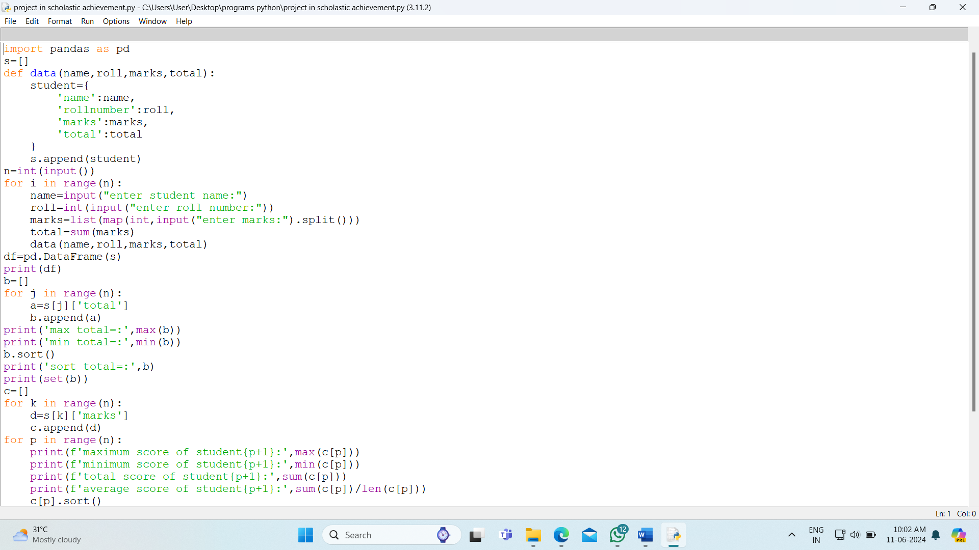

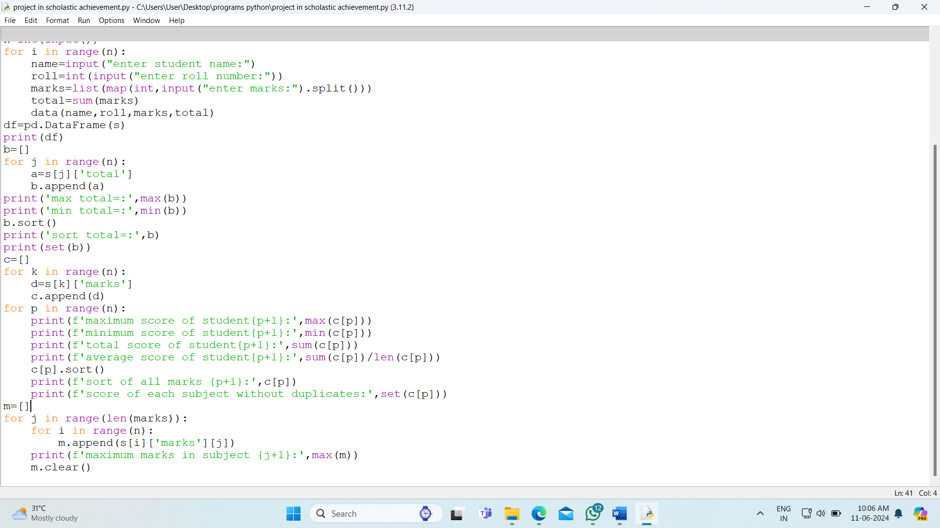

Output:

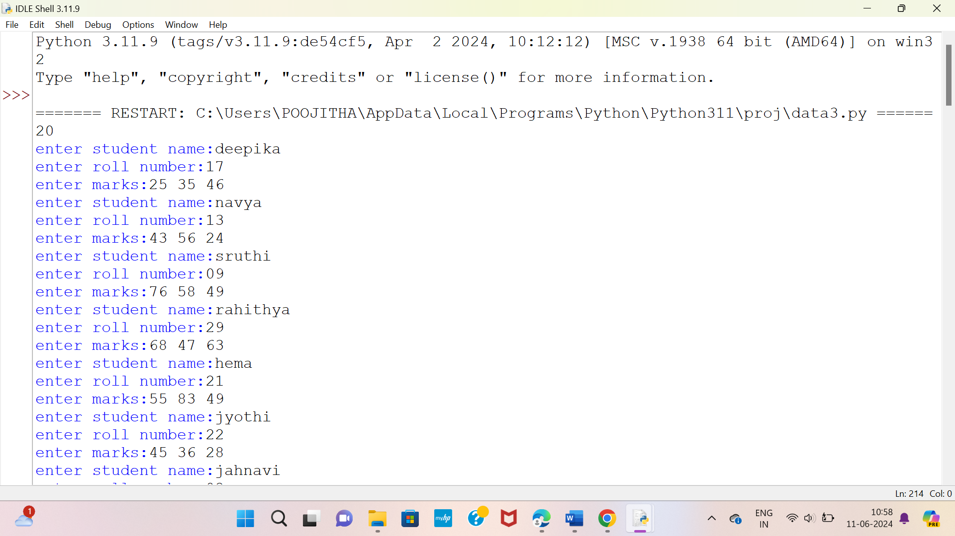

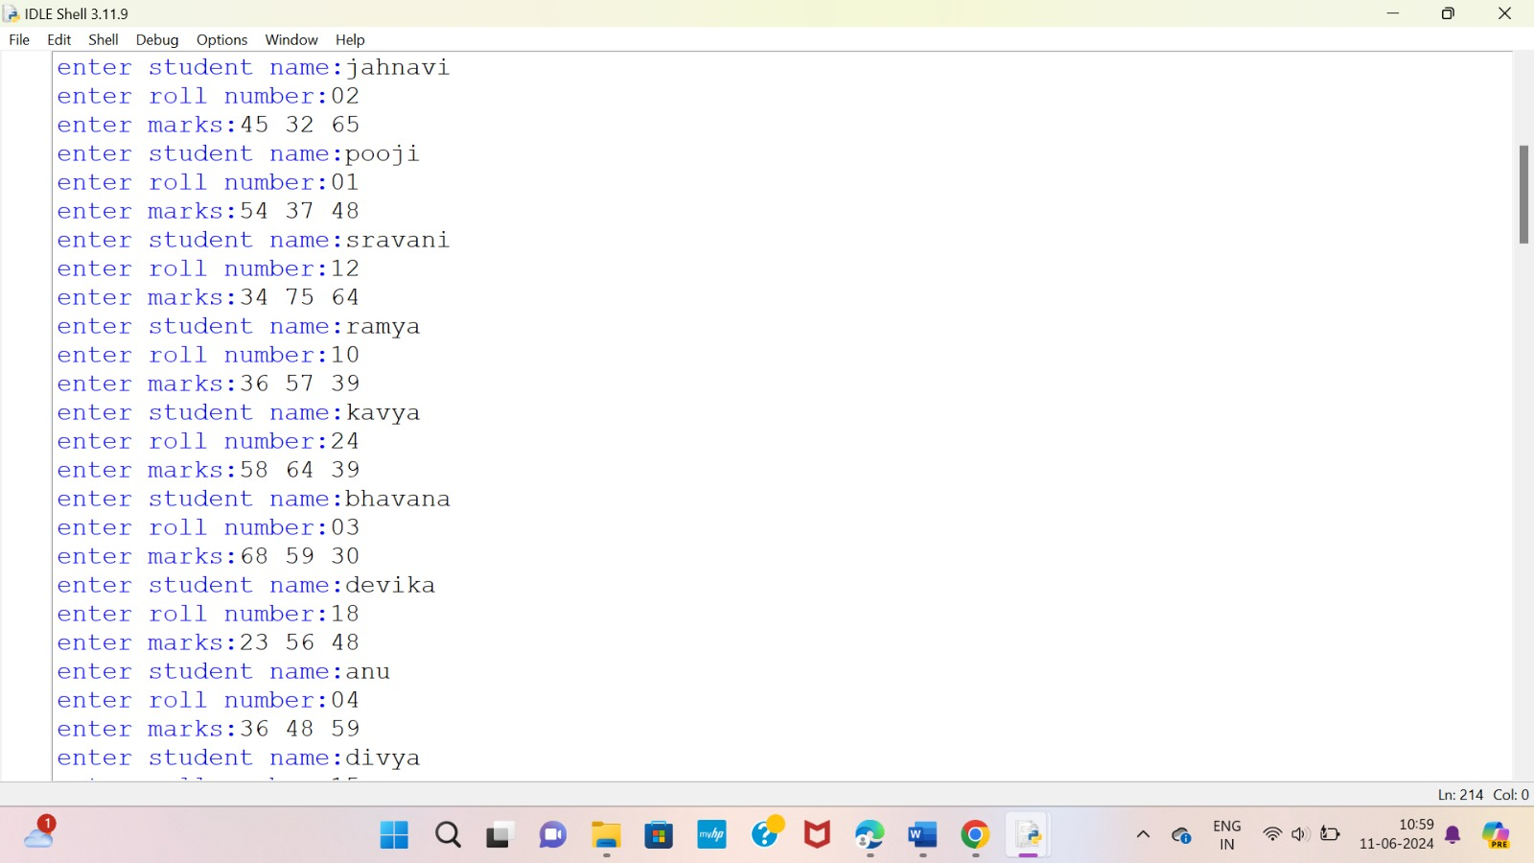

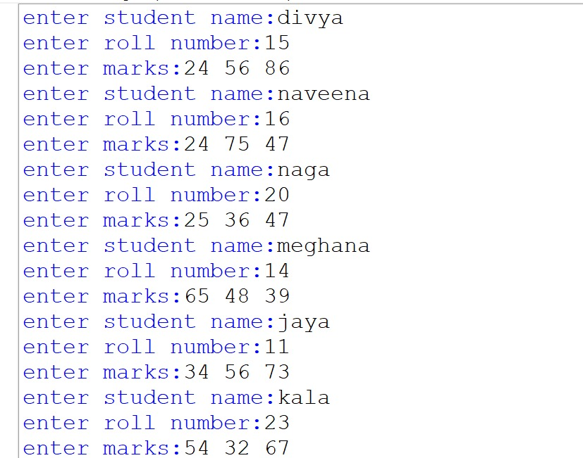

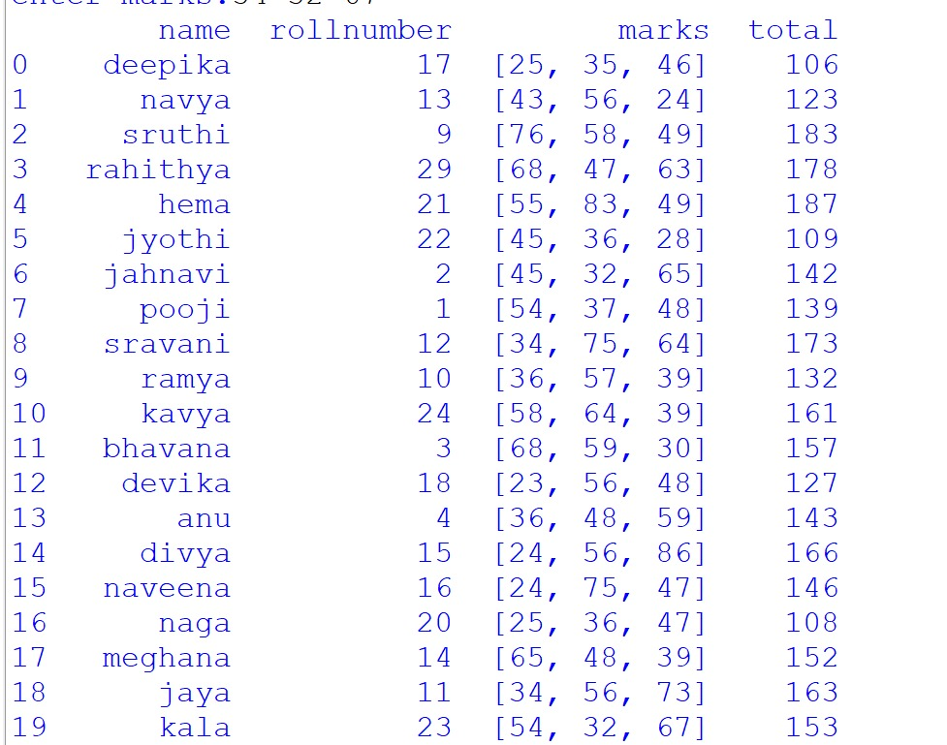

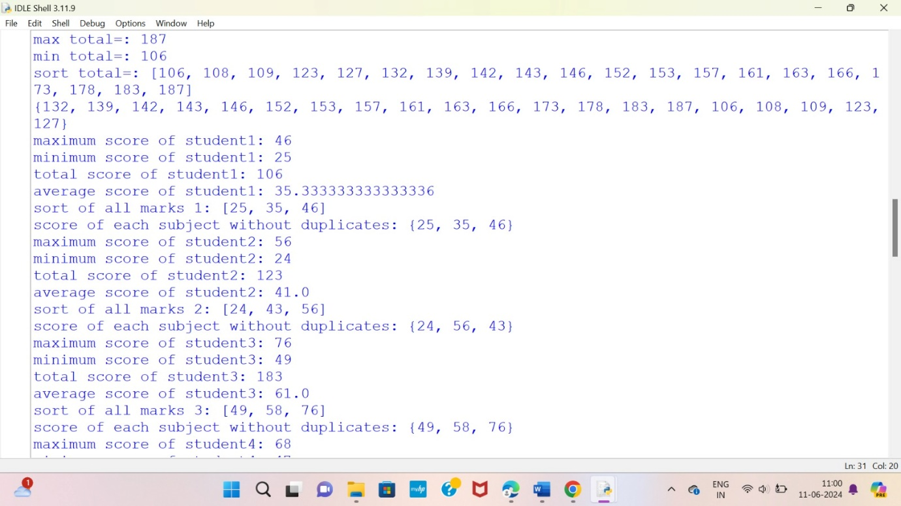

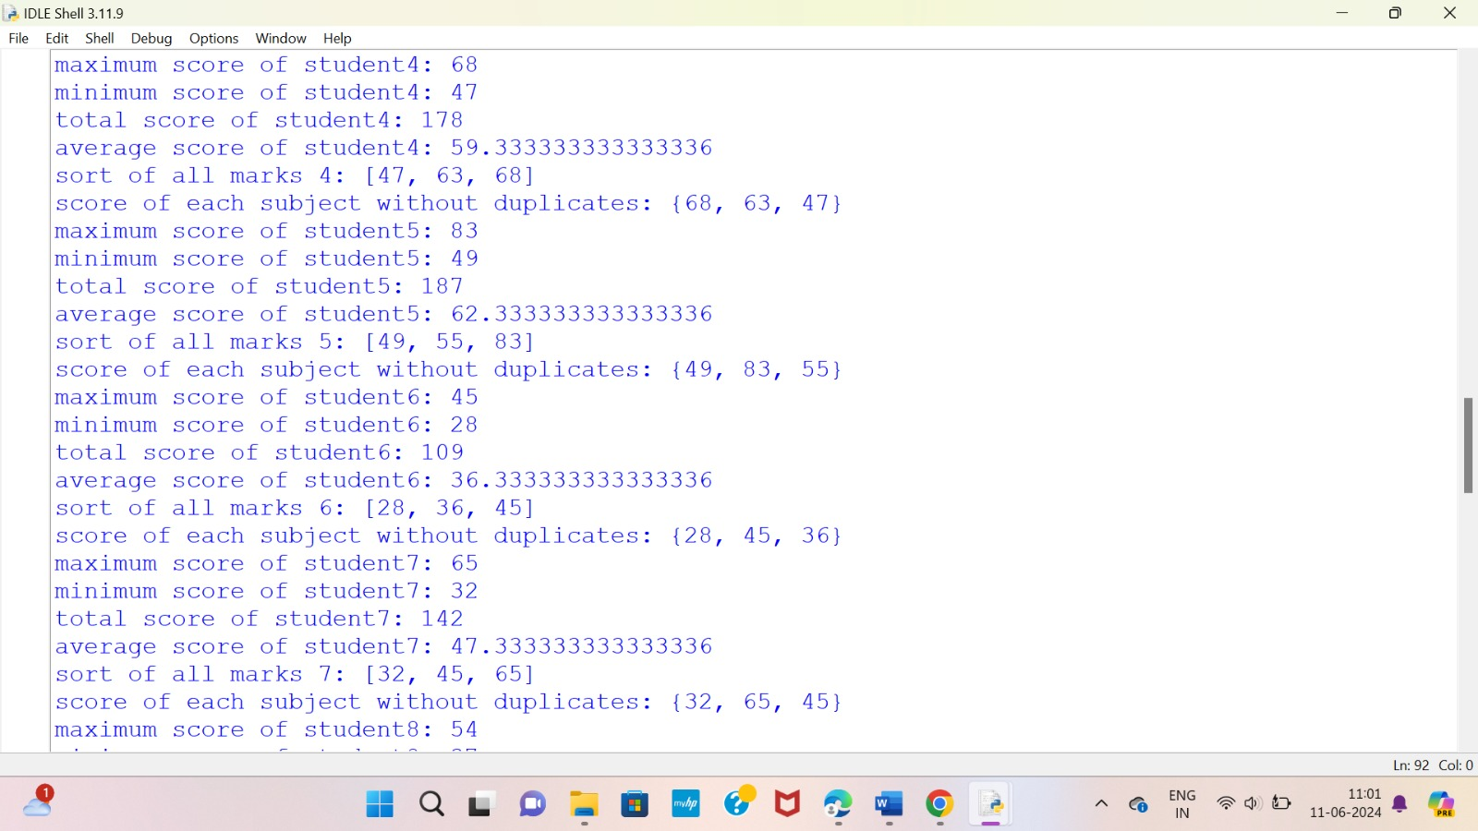

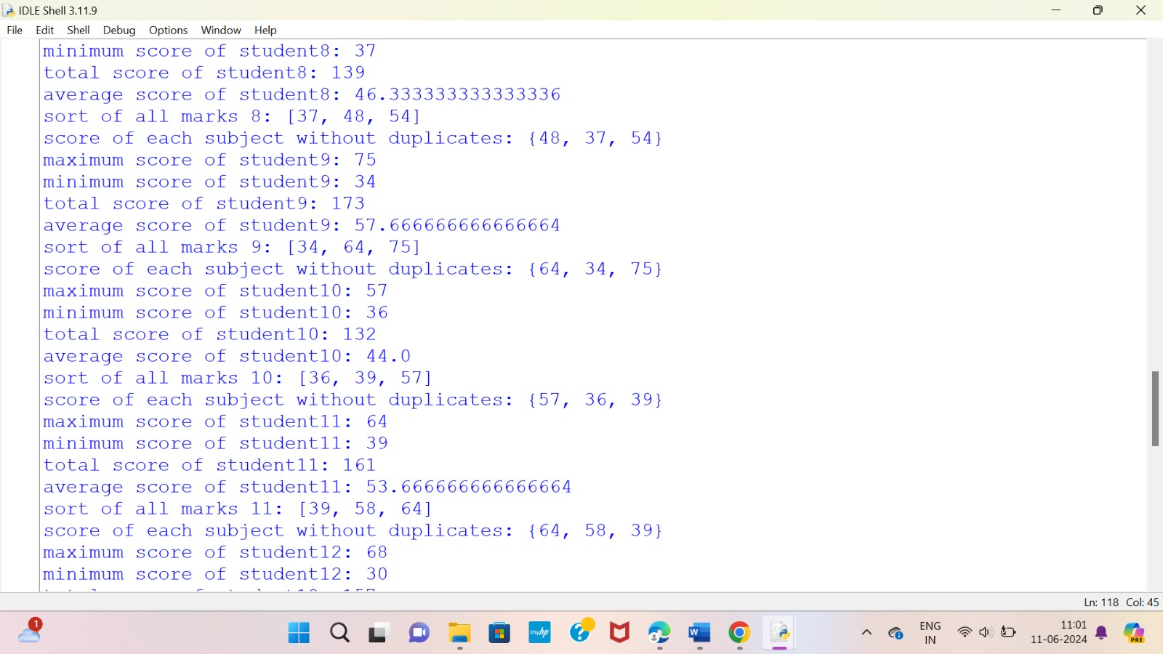

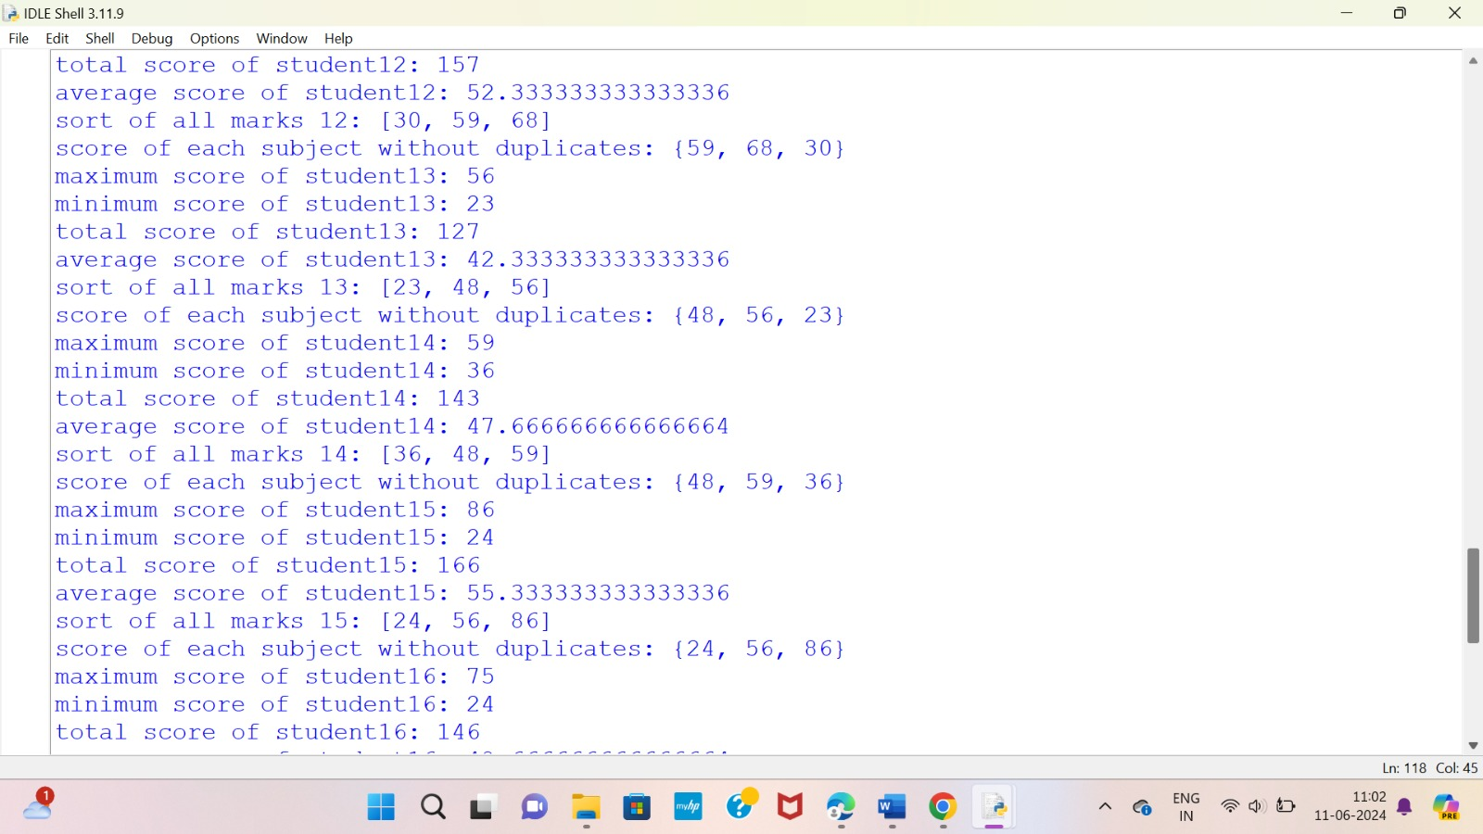

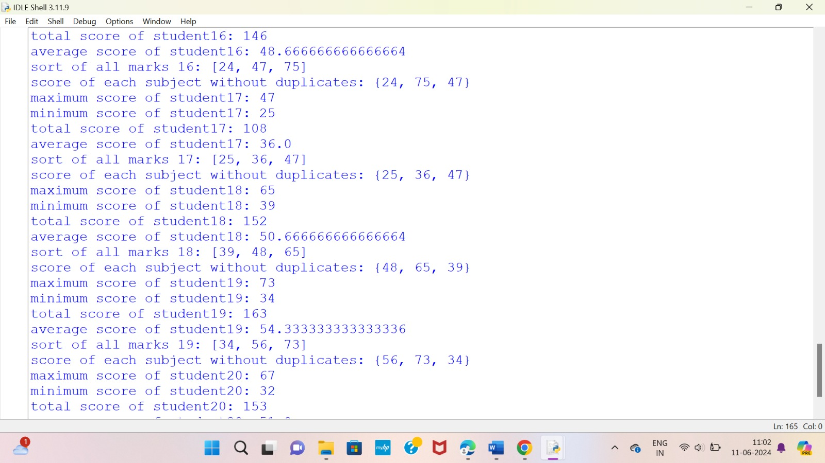

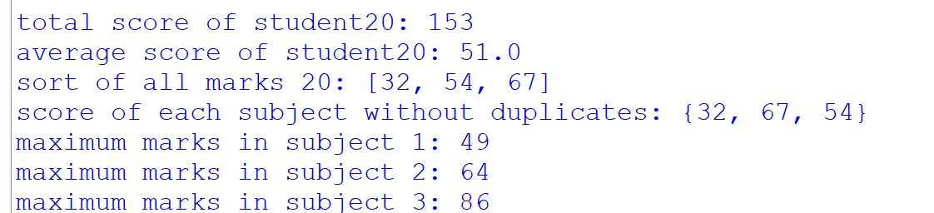

Explanation: This Python code allows for the input of student data, performs various operations on the data, and then prints the results. Here's a step-by-step explanation of the code:

Imports and Initial Setup:

import pandas as pd: Imports the pandas library for data manipulation.

s = []: Initializes an empty list s to store student data.

Function Definition:def data(name, roll, marks, total): Defines a function data that takes four arguments: name, roll, marks, and total.

Inside the function, a dictionary student is created with the keys 'name', 'rollnumber', 'marks', and 'total', and the corresponding values.

The student dictionary is appended to the list s.

Input and Data Collection:

n = int(input()): Reads an integer n which represents the number of students.

A loop runs n times to collect data for each student:

name = input("enter student name:"): Reads the student's name.

roll = int(input("enter roll number:")): Reads the student's roll number.

marks = list(map(int, input("enter marks:").split())): Reads the marks as a space-separated string, splits it into a list of integers.

total = sum(marks): Calculates the total marks for the student.

The data function is called with the collected data.

Creating DataFrame:

df = pd.DataFrame(s): Creates a pandas DataFrame df from the list s.

print(df): Prints the DataFrame, showing all students' data.

Total Marks Operations:

b = []: Initializes an empty list b to store total marks of each student.

A loop runs through the list s to collect total marks:

a = s[j]['total']: Retrieves the total marks for each student.

b.append(a): Appends the total marks to list b.

print('max total=:', max(b)): Prints the maximum total marks.

print('min total=:', min(b)): Prints the minimum total marks.

b.sort(): Sorts the list b in ascending order.

print('sort total=:', b): Prints the sorted total marks.

print(set(b)): Prints the unique total marks.

Individual Student Marks Operations:

c = []: Initializes an empty list c to store marks of each student.

A loop runs through the list s to collect marks:

d = s[k]['marks']: Retrieves the marks for each student.

c.append(d): Appends the marks to list c.

Another loop runs through each student's marks to perform various operations:

print(f'maximum score of student{p+1}:', max(c[p])): Prints the maximum score of each student.

print(f'minimum score of student{p+1}:', min(c[p])): Prints the minimum score of each student.

print(f'total score of student{p+1}:', sum(c[p])): Prints the total score of each student.

print(f'average score of student{p+1}:', sum(c[p])/len(c[p])): Prints the average score of each student.

c[p].sort(): Sorts the marks of each student.

print(f'sort of all marks {p+1}:', c[p])): Prints the sorted marks of each student.

print(f'score of each subject without duplicates:', set(c[p])): Prints the unique scores of each student.

Marks by Subject Operations:

m = []: Initializes an empty list m to store marks of all students for each subject.

A nested loop runs through each subject to collect marks:

For each subject, the inner loop runs through each student's marks and appends them to list m.

print(f'maximum marks in subject {j+1}:', max(m)): Prints the maximum marks in each subject.

m.clear(): Clears the list m for the next subject.

This code covers various aspects of student data processing, including input collection, DataFrame creation, summary statistics, and detailed operations on individual student marks and subject-wise analysis.

Conculsion:

Achieving scholastic success is a comprehensive and dynamic process that requires a concerted effort from educators, students, parents, and the community. By focusing on individualized instruction, effective teaching practices, supportive learning environments, and robust community involvement, schools can create an atmosphere that fosters academic excellence.